Mak Vasic

# Quest for glory

You are sitting in office, quite an ordinary day. Nothing was pointing out that this will be most important day for hero in his rising up to glory.

Sudenlly….out of nowhere, mail appears in your inbox….what will you do?

1. Ignore the mail…..you are not a hero … (go to Ichigo…Kurosaki…Ichigo)



1. This is what I’ve been waiting for, I will open the CASE (go to Hero in its making)



# Hero in its making

Sudenlly….. Le wild Dakinsa appears asking to open the CASE.



A ) Great….i have better things to do…let him open it (go to Problem?)



1. No…..Sometimes man has to do…what man has to do (go to Clark Gable)

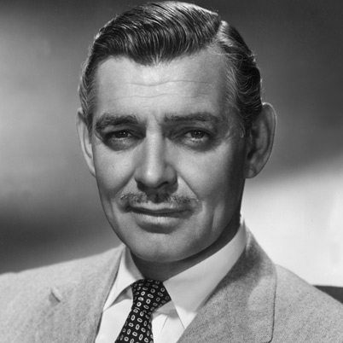

# Clark Gable

As you embark on quest of great…no…EPIC proportions, you must choose how to deal with upcoming menace…

1. Seems I can do it….after all… (go to sand castle)

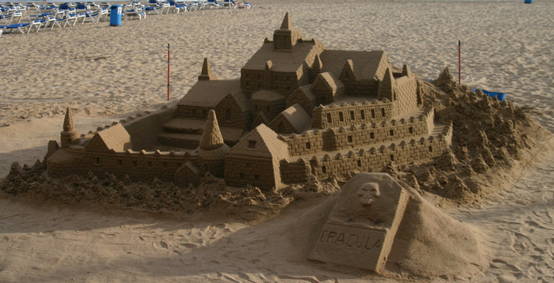

1. I cant do it after all…i need to search for quest companions (go to hero party)

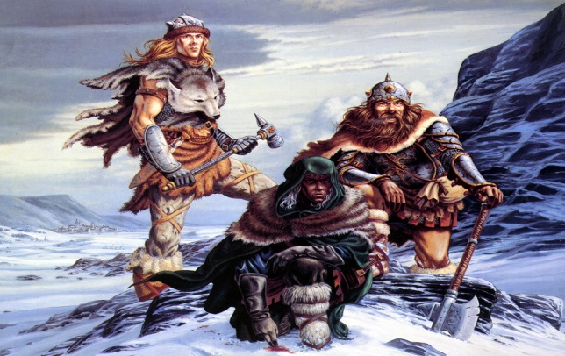

C ) Who cares…..i am Tier 1 hero anyway.. (go to page Loshmi The Gray)



# Hero party

As you enter smoky old dusky tavern, you can see several hard looking fellas, who go about their own business….seems no one of them is noticing you coming in…

A ) I will ask party of semi-veterans, they look capable of doing the muscle work for me (go to Tier 2)

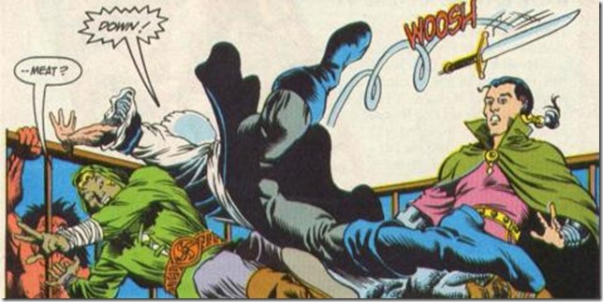

B ) I chose to ask veteran party…better to have more than less..

(go to page Tier 3)

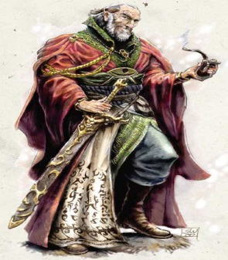

C ) I will ask Dakinsa…old friend from thousands battles to help me…more XP for both of us… (go to Dacha theTurkish terror)

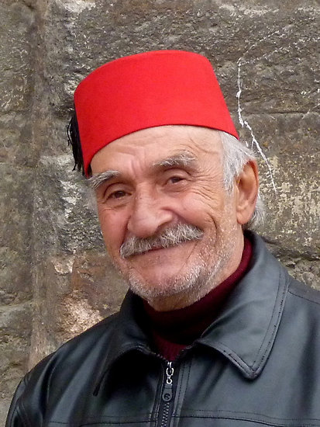

# Tier 2

You approach table of Tier 2 party….and you notice 2 heroes who could help you on your journey. Time to choose…choose wisely…

1. I will ask for Trba the Bard….His epic singing will inspire our party for glorious events…and keep us awake.. (go to page Song of the siren)



B ) A Sage is what we need, his rich experience and way with words…and his engineering skills..(go to page Goran the Pervy sage)



# Song of the siren

Oh NOOO….Trba the siren is in singing mode, the song that just started is from Gotye-Somebody that i used to know …..it is to hard to resist urge to run away….what will you do ?

A ) I…can’t…fail…now….must…resist… (go to page Cheese in ears)



B ) It’s to strong…i must back down…for now (go to Run to the hills)



# Cheese in ears

As you approach song becomes more and more louder…you feed like your head will burst, and the pain makes you forget what was your quest in first place, you must make save check in order to resist the spell.

A ) You rolled the dice for resist check and you rolled 5 (go to I am alive, I am alive)



B ) You rolled the dice for resist check and you rolled 3 (go toThis is the end...my only friend)



# Goran thePervy Sage

Goran the sage is sitting in his high chair…looking very busy, but you already feel aura of wisdom spreading around him, like it suits to someone who spent so many years studying and in search of knowledge. As you come near him you see that :

A ) He is on Tagallicious checking the young girls online (go to Boys will be boys)



B ) He is reading the last copy of Sage’s popular magazine, called Kurir (go to Letters form Iwo Jima)

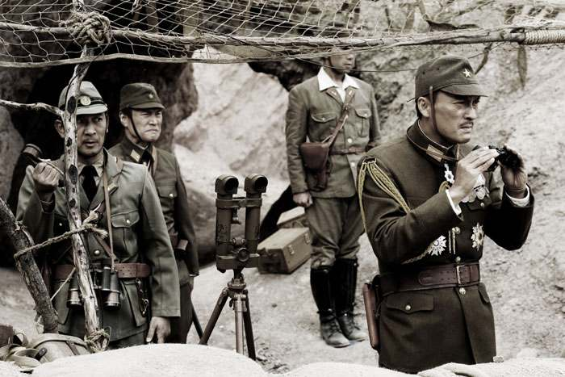

# Boys will be boys

The girl he is using his ancient and wise seducing methods, is a lady of great beauty, one you see in lifetime, that you cry out in cold nights and whose name will never make your lips forget them

A ) Stop overreacting, she is not that good at all…moderate at best.. (go to Different tastes)



B ) Wow…she does look like bomb… or will be in 5 years (go to page Grab the chance while you can)

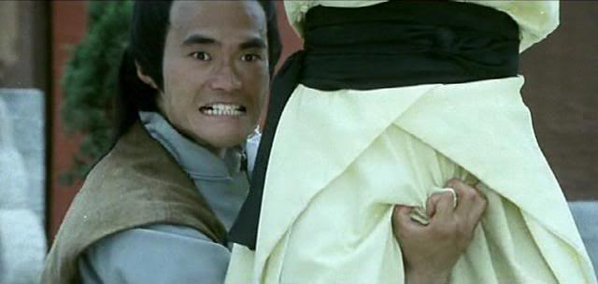

# Turkish terror

Dakinsha, young and naïve hero wannabe, is skulking around you, waiting to get chance for his piece of glory. After you gave him chance to become famous, he turns his all power into solving CASE.

A ) He tries…harder and harder, and somehow he miraculously does it (go to Sand castle)



B ) After hours of trying, he fails to open the CASE, His weapon must be under VPN curse, and therefore unable to open CASE in this realm..(go to Wheel of time)

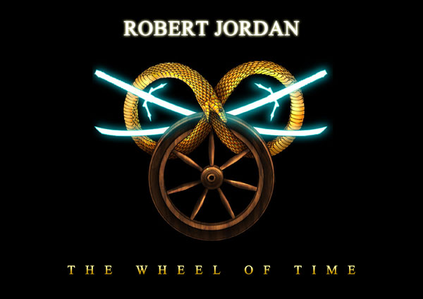

# Letters from Iwo Jima

In his wisdom, the wise and pervy sage, pays no attention to your young crew of adventurers. Of course you cant just bump in, risking that your insolence shall be severely punished, soooo you chose a more…tactical approach…

A ) Start apparently naïve conversation with Dakinsa about new dungeon named Avaya Patches 6.2 that appeared in hills nearby, swarming with monsters and treasure..(go to Saving private Ryan)

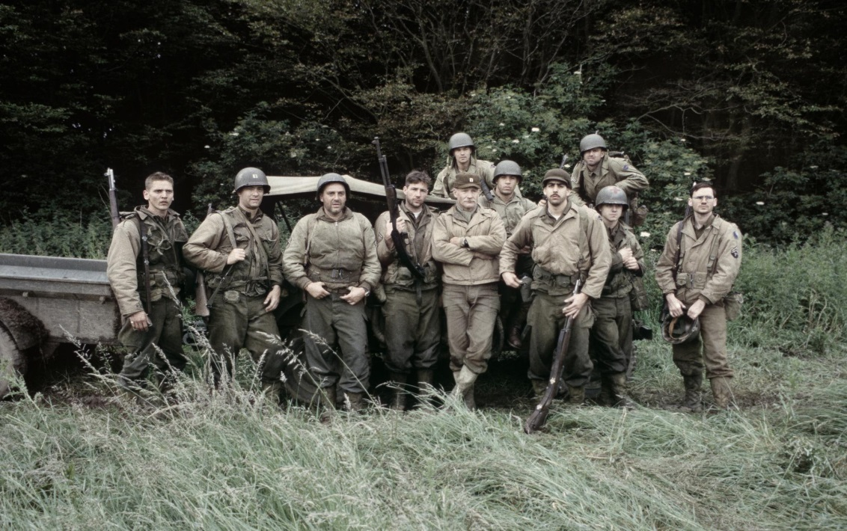

B ) In land far away, battle outbursts between sentinel and dire forces…with many famous heroes on both sides, clash will happen of the fields of DotA…(go to Battle of heavens)

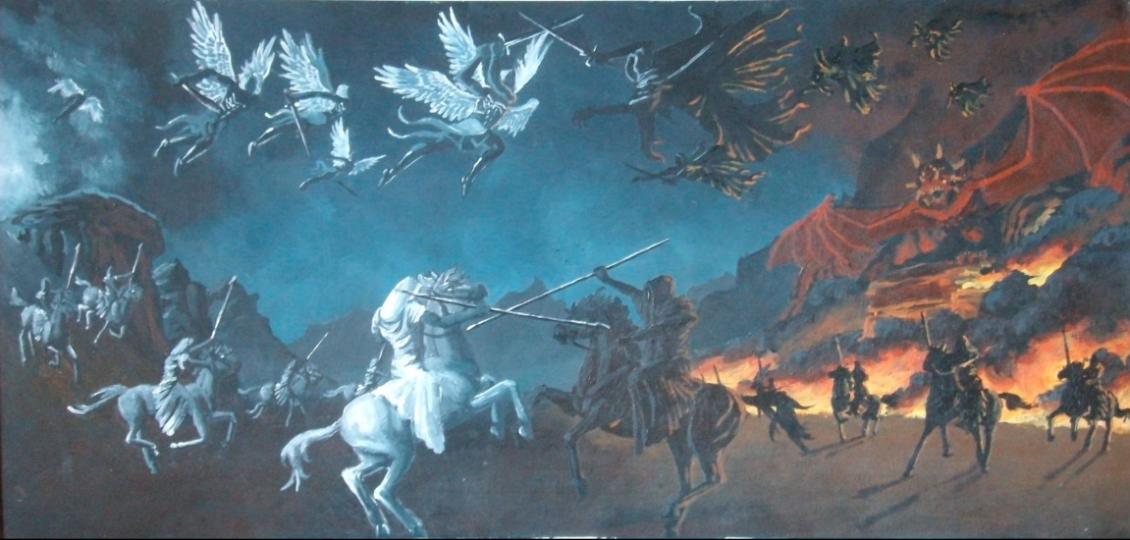

# Saving private Ryan

It is working….Hearing of unknown dungeons, Goran the pervy sage slowly raises, and approaches your party…now its time to roll the dice …

A ) There are no dungeons, i made it up, it was all made up from beginning.. (go to Do or be done)



B ) See there, before we start working our Dungeon raid plan, could you please cast a gaze upon this quest? (go to Grab the chance while you can)



# Different tastes

Goran the pervy sage is willing to help you, because maiden was not worth saving, after 5-6 consulting’s with Tier 3 group, you are ready to embark on glorious quest of solving the CASE (go to page Sand Castle)



# Tier 3

There is one table in the corner of tavern, and amidst smoke and fumes, there are two shady characters. You can’t see well their faces, it’s like the light itself avoids touching their faces, as just showing their faces would cast unbelievable terror on other tavern guests.

A ) A mage…..whose gray hair shows ages of solving CASE’s, whose words bring joy to those who listens to them, like wisdom itself pours from them , and like your intellect is rising from just hearing those words…(go to Loshmi The Gray)



B ) A warrior….who else…he maybe don’t have the brains, but when it comes to muscle power, he is unmatched. Only thing that can match his power is his belly, that looks more like rising mountain than ordinary person’s stomach…They call him Milan earth shaker (go to page Hatori Hanzio)

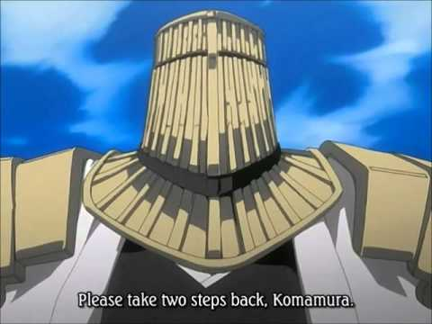

# LoshMi The Gray

As you expose your problem to LoshMi, you can see hint of his smile, as would you look upon child who would try to fight his way with wooden sword against old Oak tree…

A ) Young one, if you want to hear my advice, go far to the north, ` where mountains touch the sky, where clouds dance among eyes of ones who watch it. There will you find Pedja the oracle (go to page Soothsayer)

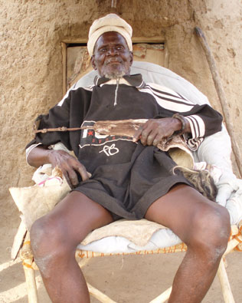

B ) I help you will….if you do thou quest for me (go to Bridge of doom)

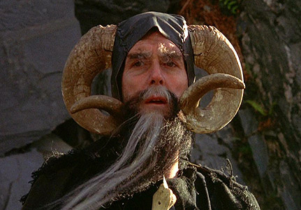

# Battle of Heavens

A wild conversation bursts out, what hero will fare best, who will win, where to go, what items to buy, what skills to build, who will support who, who will carry, who will feed….…the troops. And you forgot about CASE at all, before you know it, it’s 17.00 h, tavern closing time. (go to page Wheel of time)



# Grab the chance

You ménage to convince the Sage to help you, using flattery, and sweet talk. After a while, he is in a good mood, he takes on himself to ask noble warriors from Tier 3, and you can (go to page Sand Castle)



# Hatori Hanzo

A warrior is playing dice with some shady characters. At first, you try to wait, but soon you realize this will take to long to wait, so you chose to make your first move.

A ) You try to attract his attention and roll the dice for Charisma check . You rolled 2 (go to page Alea Iacta Est)



B ) You try to attract his attention and roll the dice for Charisma check . You rolled 4 (go to Disaster in its making)



# Do or be Done

After hearing that it was all a lie, Goran bursts into rage and starts…dancing!? Though the dance was somewhat smooth and catchy, you couldn’t stand that amount of rhythm, it was like river flushing to your face , with its wild currents. So you chose bravely to…retreat….for now..

(go to Run to the hills)

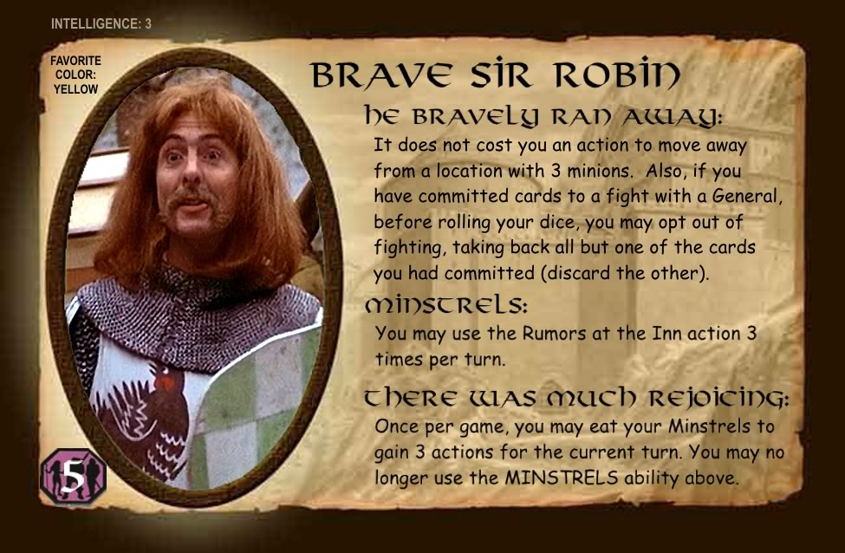

# Problem?

Leave those poor fools doing all the hard work. Why i don’t i just sit down and start reading new hero daily magazine, about other fools doing the hard work. You would rather sit and enjoy pint of beer….



End of story.

Don’t like this?

Go to Quest for glory

# Sand Castle

You made it….CASE is solved, and you can bask in your glory.

From town to town, your name will be singed, young virgins will repeat your name in their dreams, and jealous husbands will curse you because after tale of your deeds they will never be top male in their wife’s hearts.



End of story.

Don’t like this?

Go to Quest for glory

# Wheel of time

Wheel of time turns, and ages come and go. Ages turns to memories, memories turned to myths, and even myths are long forgotten after that age which gave them birth comes to the end. In one such age, there was hero named MakVas, but he failed in his quest. Only thing that left, is whispering of wind in the trees, that one CASE remained unsolved.



End of story.

Don’t like this?

Go to Quest for glory

# Soothsayer

After a while, you find deep into mountains, behind seven seas and seven hills, where ancient people left their lands because they didn’t have anything to do…you finally find Pedja the Oracle. You ask for piece of advice, and after a while you get answer…

1. There is not CASE’s that can’t be solved (go to page Sand Castle)



B ) You must gather your strength, in order to finish this my son…when choosing path, it’s not important how long the path is, but the determination to go until end…ask Sirene for advice (go to page I am alive, i am alive)

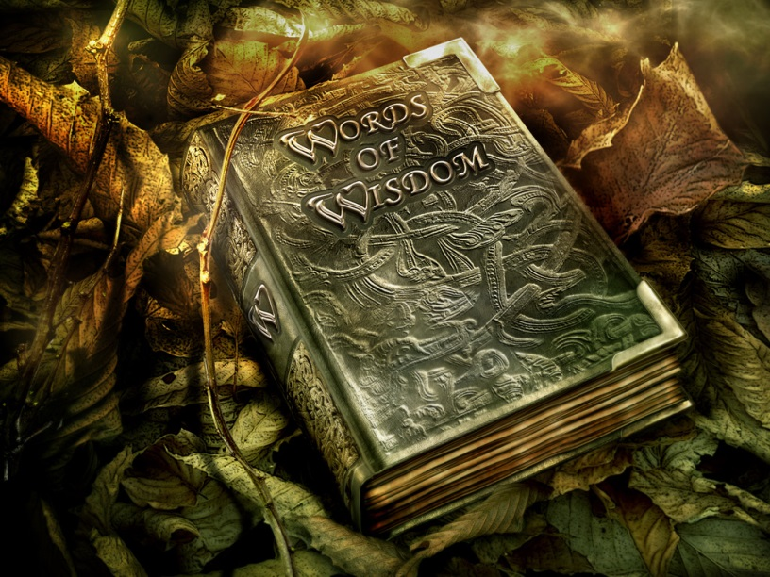

# Bridge of DOOM

LoshMi the mage eyed you up and down as considering will you be up for the task….then he decides that you may be Tier 1 hero, but there is something heroic inside you….so he gives you choices…

A ) Go in to the wilds of Winner, and hunt me some food…if you survive that is…(go to rare beast of Becka)

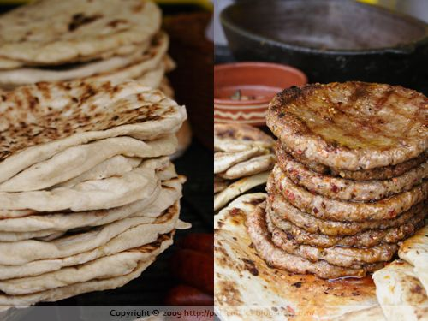

B ) I have no time for you, go to Milan theEarthShaker and ask for his advice…. (go to Hatori Hanzo)

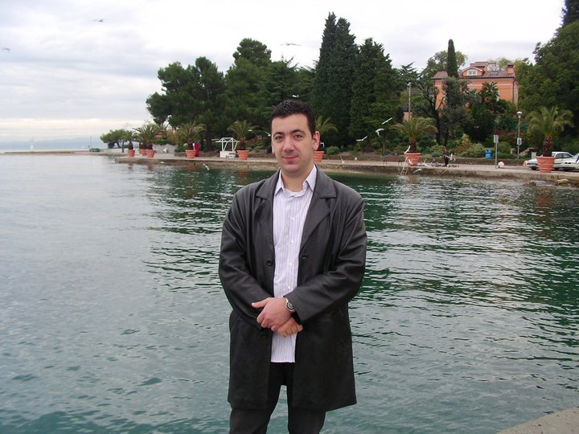

# I am alive

After surviving Trba the Siren’s song, you asked her for advice, and she agrees to help you, in exchange for turning on ancient radio that barbarians broke so that Siren couldn’t sing anymore. (go to Sand Castle)



# This is the end…

Your head exploded from overpowering song, your bones scattered by wind, left to jackals to feast upon them. Not the first, nor the last one who was killed by Siren’s song. Tales of your bravery shall travel the land, inspire all future generations of young heroes….well, probably not…(go to Wheel of time)



# Alea Iacta Est

After you said number 2, Milan the EarthShaker answered number 2, and since it was correct answer in ancient game of Asocijacije, he won. Therefore he was happy and decided to help you with your quest…(go to page Problem?)

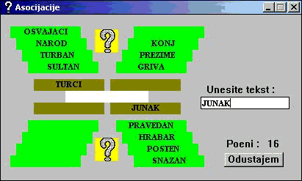

# Disaster in its making

Only fools would dare to interrupt Milan the EarthShaker while playing Slagalica with beautiful Milka Canic….In a flashing of en eye, you were whipped out from this world, last thing you heared was 四方八方手裏剣

(go to Wheel of time)

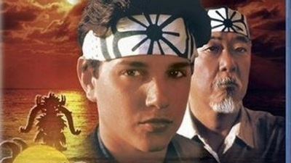

# Run to the hills

Time to gather strength, lick the wounds, and prepare to great comeback, this time you will be wiser, faster, smarter…well not sure about this last.. (go to Hero Party)



# Ichigo….Kurosaki Ichigo

You pierced sword through one ninja’s chest, by corner of the eye, you noticed 4 more coming from behind. You throve shurikens just to get some time, knowing that it can’t do any harm to this hard cored ninjas. But that was enough, you grabbed first ninja for arm and used him as shield against piercing attack from…..and then you woke up…It was about time, another day finished…you can go (go to page Problem?)

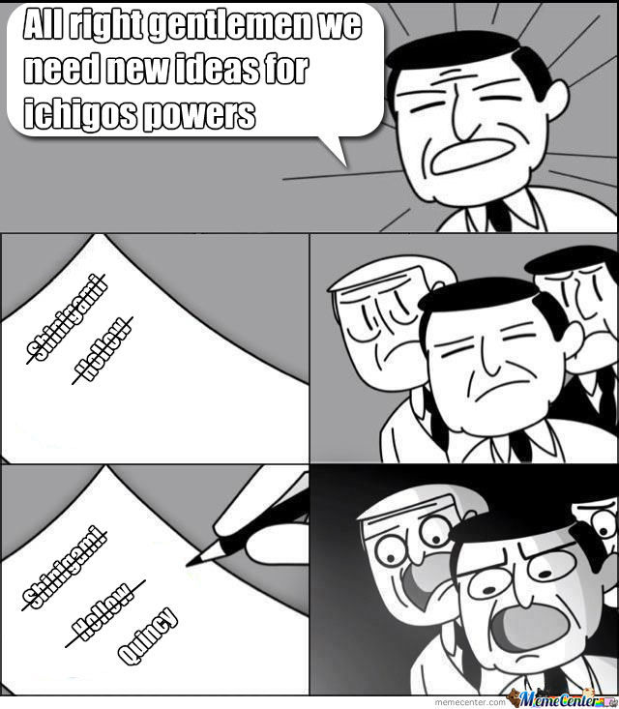

# Rare beast of Becka

After approaching wilds of Winner, you wonder what sort of animal would that be, so terrifying that even LoshMi the mage wouldn’t dare go hunting it. And then you saw it….jaws like white shark, fangs of the saber tiger,…yes…you can see it clearly now…mythical creature…Pragnje..

1. I cant capture it alone….i need new teammate to help me in this task….(go to Tier 2)

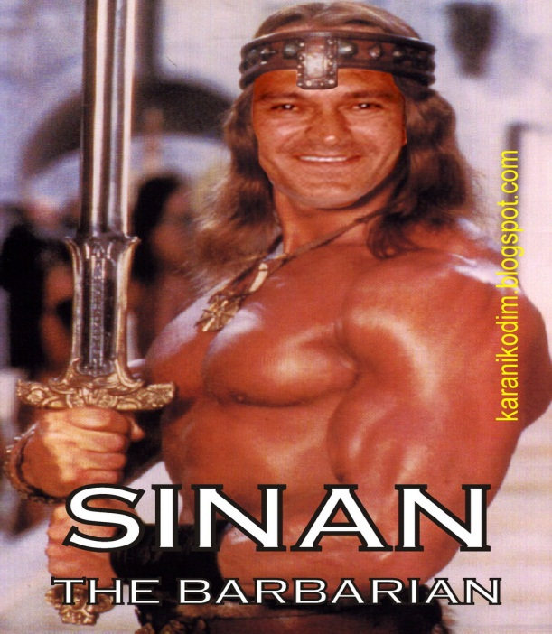

1. I can solo this, no help needed…. (go to Eat or be eaten)



# Eat or be eaten

You fought bravely. Exchanging hit by hit with monster, and fight lasted deep into night, with last ounce of power you tried to throw axe between its eyes…

1. You rolled 5 (go to Hunter or pray?)



B ) You rolled 6 (go to Solo mid?)



# Hunter or pray

You failed miserably, and was promptly eaten. Maybe you were third grade hero, but you were first class meal on Pragnje’s table…(go to Wheel of time)



# Solo mid?

You one-shoted Pragnje, killing it in its tracks. Bringing this beast to LoshMi the mage would surely make him satisfied.

And so it did…..in fact, he was so satisfied, that he decided to help you in your epic quest of epic proportions, with epic contenders and epic things yet to happen….(go to Sand Castle)

